CHANDIGARH UNIVERSITY
University Institute of Computing

MINI PROJECT REPORT
ON
PERSONAL FINANCE AND EXPENSE ANALYTICS SYSTEM
PYTHON PROGRAMMING
(26CAH-606)

Submitted By: Submitted To:
Arpit Saxena Pawandeep Sharma
26MCD10006 E2916
MCA (Data Science)
26MCD-1 (A)


Master of Computer Applications (MCA)
University Institute of Computing
Chandigarh University,
Gharuan, Mohali, Punjab, India-140413

TABLE OF CONTENTS
S. No. | Contents | Page No.
1 | Certificate | 1
2 | Declaration | 2
3 | Acknowledgement | 3
4 | Abstract | 4
5 | Introduction | 5
6 | Problem Statement | 5
7 | Objectives | 5
8 | Scope of the Project | 6
9 | Existing and Proposed System | 6
10 | Technologies Used | 6
11 | System Requirements | 7
12 | System Architecture | 8
13 | Database Design | 9
14 | Project Modules | 9
15 | Implementation | 10
16 | Important Code Snippets | 11
17 | Testing and Results | 13
18 | Output Screenshots | 14
19 | Conclusion and Future Scope | 17
20 | References | 18

CERTIFICATE
This is to certify that Arpit Saxena, a student of Master of Computer Applications (MCA) – Data Science, 1st Semester, at Chandigarh University, Mohali, has successfully completed the mini-project entitled “Personal Finance and Expense Analytics System” as part of the academic requirements for the Python Programming Lab during the academic session 2026–2027.
The project demonstrates the practical application of Python programming, SQLite database management, NumPy, Pandas, Matplotlib, and Tkinter in developing a desktop application for personal financial management, expense tracking, budget monitoring, statistical analysis, and data visualization.
The project has been completed under faculty guidance and is submitted in partial fulfillment of the academic requirements of the MCA (Data Science) programme.
Faculty Guide / Project Evaluator: __________________________
Student Signature: __________________________
Date: __________________________

DECLARATION
I, Arpit Saxena, hereby declare that the mini-project entitled “Personal Finance and Expense Analytics System” is my original academic work, carried out as part of the Master of Computer Applications (MCA) – Data Science, 1st Semester programme at Chandigarh University, Mohali.
The project has been developed as part of the Python Programming Lab during the academic session 2026–2027. The work presented in this report reflects my understanding and practical application of Python programming, database management, data analytics, and data visualization.
I hereby declare that this project report has been prepared for academic purposes and that the work presented is submitted in partial fulfillment of the academic requirements of the MCA (Data Science) programme.
Student Signature: __________________________
Date: __________________________

ACKNOWLEDGEMENT
I would like to express my sincere gratitude to Mrs. Pawandeep Sharma for his valuable guidance, support, and encouragement throughout the development of my mini-project, “Personal Finance and Expense Analytics System.” His guidance and suggestions helped me understand the practical application of Python programming, database management, data analytics, and data visualization.
I am also thankful to Chandigarh University and the University Institute of Computing (UIC) for providing the necessary academic environment, facilities, and resources to complete this project successfully as part of the MCA (Data Science) programme.
I would also like to thank my teachers and everyone who supported me directly or indirectly during the development and testing of this project. This project has been a valuable learning experience, allowing me to enhance my programming skills and apply theoretical knowledge to a real-world problem.

ABSTRACT
The Personal Finance and Expense Analytics System is a Python-based desktop application designed to simplify personal financial management by helping users track their income, expenses, and monthly budgets. The system provides an organized platform for recording financial transactions, monitoring spending patterns, and analyzing financial data efficiently.
The application is developed using Python and integrates several technologies, including SQLite for database management, Pandas and NumPy for data processing and statistical analysis, Matplotlib for data visualization, and Tkinter for the graphical user interface. It allows users to add and delete transactions, categorize income and expenses, set monthly budget limits, monitor budget utilization, and export transaction records to CSV files.
The system also calculates important financial metrics such as total income, total expenses, net savings, savings rate, mean, median, and standard deviation of expenses. Graphical representations, including expense distribution charts and monthly income-versus-expense charts, help users understand their financial habits and make informed decisions.
The main objective of this project is to demonstrate the practical application of Python programming, database connectivity, data analytics, and visualization in solving real-world financial management problems. The proposed system offers a simple, efficient, and offline solution for maintaining financial records and promoting better budgeting and spending discipline.

1. INTRODUCTION
The rapid proliferation of cashless transactions via Unified Payments Interface (UPI), contactless credit cards, and digital wallets has exponentially increased daily micro-transactions. Without structured monitoring, discretionary expenditures frequently exceed budgeted limits. Python delivers an ideal foundation for data-centric software through clean syntax, rich standard modules, and robust scientific packages. Designed as a 3-tier desktop architecture, the application empowers users to record daily income and expenses across standardized categories, maintain category spending caps with variance alerts, compute rigorous descriptive statistics, export data to CSV, and visualize spending habits through interactive charts.

2. PROBLEM STATEMENT
Managing personal finances effectively can be challenging due to manual record-keeping, calculation errors, and difficulties in tracking daily income and expenses. Many individuals struggle to monitor monthly budgets, calculate savings, and identify unnecessary spending. Traditional methods also lack automated analysis and visual representations of financial data. This project aims to address these problems by developing a Python-based desktop application that simplifies transaction management, monitors budgets, calculates financial statistics, and visualizes spending patterns to support better financial planning and decision-making.

3. OBJECTIVES
- To manage income and expenses efficiently.
- To store financial records using SQLite.
- To set and monitor monthly budgets.
- To calculate savings and financial statistics.
- To analyze expenses using Pandas and NumPy.
- To visualize financial data using Matplotlib charts.
- To export transaction records to CSV files.
- To provide a user-friendly interface using Tkinter.

4. SCOPE OF THE PROJECT
The Personal Finance and Expense Analytics System is designed to help users manage income, expenses, savings, and monthly budgets through a simple Python-based desktop application. It uses SQLite for data storage, Pandas and NumPy for financial analysis, Matplotlib for graphical visualization, and Tkinter for the user interface. The system supports transaction management, budget monitoring, financial summaries, and CSV data export. In the future, it can be enhanced with receipt scanning and machine learning-based expense prediction.
5. EXISTING AND PROPOSED SYSTEM
Existing System
Traditional financial management methods, such as handwritten records and spreadsheets, require manual data entry and calculations. These methods can lead to errors and make it difficult to monitor budgets, analyze spending patterns, and compare monthly income and expenses.
Proposed System
The proposed Personal Finance and Expense Analytics System is a Python-based desktop application that automates financial record management and analysis. It uses SQLite for data storage, Pandas and NumPy for calculations, Matplotlib for charts, and Tkinter for the graphical interface. The system enables users to manage transactions, set budgets, monitor expenses, calculate savings, and export records to CSV files efficiently.

6. TECHNOLOGIES USED
The following technologies and libraries are used to develop the Personal Finance and Expense Analytics System:
- Python: The main programming language used to develop the application and implement its functionality.
- SQLite: Used to store and manage financial transactions and budget records in a local database.
- Pandas: Used for organizing, processing, and analyzing financial data.
- NumPy: Used to perform statistical calculations such as mean, median, and standard deviation.
- Matplotlib: Used to create charts for visualizing expenses and comparing monthly income with expenses.
- Tkinter: Used to develop the graphical user interface (GUI) for user interaction.
- CSV: Used to export transaction records for external use and further analysis.
- Python 3.13: The Python version used for developing and running the application.

7. SYSTEM REQUIREMENTS
Hardware Requirements
- Processor: Intel Core i3 or equivalent
- RAM: Minimum 4 GB
- Storage: At least 500 MB of free disk space
- Display: Standard monitor or laptop screen
Software Requirements
- Operating System: Windows, Linux, or macOS
- Programming Language: Python 3.13
- Database: SQLite
- Libraries: Pandas, NumPy, Matplotlib
- GUI Framework: Tkinter
- Code Editor: VS Code or any Python-compatible IDE

These requirements provide a suitable environment for developing and running the Personal Finance and Expense Analytics System.

8. SYSTEM ARCHITECTURE

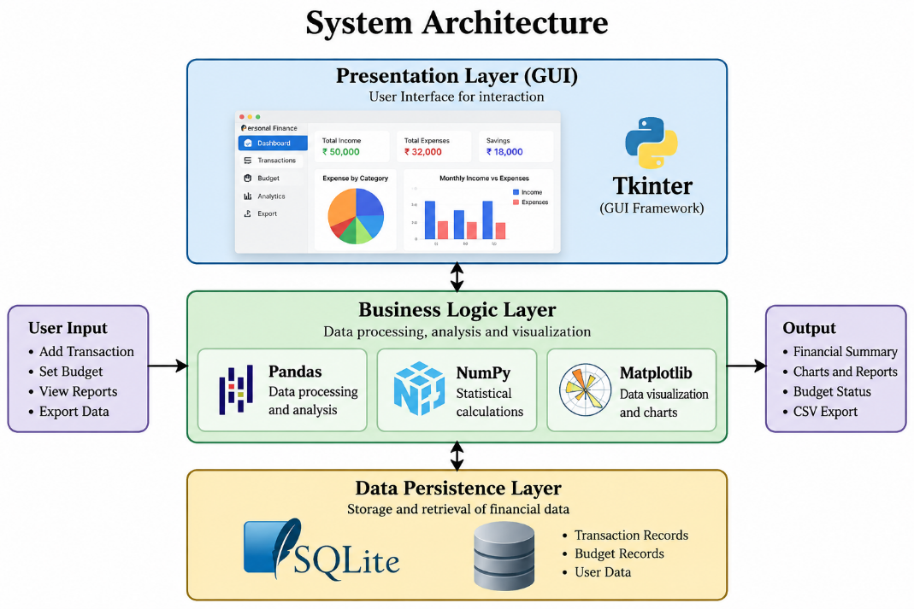

Architecture Explanation:
The Personal Finance and Expense Analytics System follows a three-tier architecture. The presentation layer uses Tkinter to provide the graphical user interface. The business logic layer uses Pandas and NumPy to process financial data, perform statistical calculations, and monitor budgets, while Matplotlib generates charts. The data persistence layer uses SQLite to store and retrieve transaction and budget records. These layers work together to provide efficient financial management, analysis, and visualization.

Architecture Layers:
- Presentation Layer: Tkinter GUI for user interaction.
- Business Logic Layer: Python, Pandas, NumPy, and Matplotlib for processing, analysis, and visualization.
- Data Persistence Layer: SQLite database for storing financial transactions and budgets.

9. DATABASE DESIGN
The system uses SQLite to store financial transactions and budget records in two tables.
- Transactions Table: Stores transaction ID, date, type, category, amount, description, and payment mode.
- Budgets Table: Stores expense categories and their monthly budget limits.
This database structure enables efficient storage, retrieval, and analysis of financial information.

10. PROJECT MODULES
The Personal Finance and Expense Analytics System consists of five main modules:
- Database Module (database.py): Manages SQLite database operations, transactions, and budgets.
- Analytics Module (analytics.py): Uses Pandas and NumPy to calculate financial statistics and analyze expenses.
- Visualization Module (visualizer.py): Creates charts for expense categories and monthly income versus expenses using Matplotlib.
- GUI Module (gui.py): Provides a Tkinter interface for managing transactions, budgets, and financial reports.
- Main Module (main.py): Initializes the application, loads sample data, and launches the GUI or command-line interface.

11. IMPLEMENTATION
The Personal Finance and Expense Analytics System is implemented using Python and its supporting libraries. SQLite manages financial records, while Pandas and NumPy perform data processing and statistical calculations. Matplotlib generates charts, and Tkinter provides an interactive graphical interface. The application allows users to add and delete transactions, set budgets, view financial summaries, analyze spending patterns, and export transaction records to CSV files.

12. IMPORTANT CODE SNIPPETS
The following code demonstrates the major functionalities of the Personal Finance and Expense Analytics System, including database management, transaction recording, budget monitoring, statistical analysis, data visualization, and CSV export.
import sqlite3
import numpy as np
import pandas as pd
import matplotlib.pyplot as plt
import tkinter as tk

# 1. Database Connection and Table Creation
conn = sqlite3.connect("finance.db")
cursor = conn.cursor()

cursor.executescript("""
CREATE TABLE IF NOT EXISTS transactions (
id INTEGER PRIMARY KEY AUTOINCREMENT,
date TEXT NOT NULL,
type TEXT NOT NULL,
category TEXT NOT NULL,
amount REAL NOT NULL,
description TEXT,
payment_mode TEXT DEFAULT 'UPI'
);

CREATE TABLE IF NOT EXISTS budgets (
category TEXT PRIMARY KEY,
monthly_limit REAL NOT NULL
);
""")

# 2. Add a Financial Transaction
def add_transaction(date, trans_type, category,
amount, description="", mode="UPI"):
cursor.execute("""
INSERT INTO transactions
(date, type, category, amount, description, payment_mode)
VALUES (?, ?, ?, ?, ?, ?)
""", (date, trans_type, category, amount, description, mode))
conn.commit()
# 3. Calculate Income, Expenses and Savings
cursor.execute("""
SELECT
COALESCE(SUM(CASE WHEN type='Income'
THEN amount ELSE 0 END), 0),
COALESCE(SUM(CASE WHEN type='Expense'
THEN amount ELSE 0 END), 0)
FROM transactions
""")

income, expense = cursor.fetchone()
savings = income - expense
savings_rate = (savings / income * 100) if income > 0 else 0

print("Total Income:", income)
print("Total Expenses:", expense)
print("Net Savings:", savings)
print("Savings Rate:", savings_rate)

# 4. Set or Update a Budget
def set_budget(category, limit):
cursor.execute("""
INSERT INTO budgets (category, monthly_limit)
VALUES (?, ?)
ON CONFLICT(category)
DO UPDATE SET monthly_limit = excluded.monthly_limit
""", (category, limit))
conn.commit()

# 5. Check Budget Status
def check_budget(spent, limit):
percentage = spent / limit * 100 if limit > 0 else 0

if percentage < 85:
status = "Normal"
elif percentage <= 100:
status = "Warning"
else:
status = "Over Budget"

return status

# 6. Analyze Expense Statistics
cursor.execute("""
SELECT amount FROM transactions
WHERE type = 'Expense'
""")
expenses = np.array([row[0] for row in cursor.fetchall()])

if len(expenses) > 0:
print("Mean:", np.mean(expenses))
print("Median:", np.median(expenses))
print("Standard Deviation:", np.std(expenses))
print("Minimum:", np.min(expenses))
print("Maximum:", np.max(expenses))
print("75th Percentile:", np.percentile(expenses, 75))

# 7. Category-Wise Expense Analysis
df = pd.read_sql_query(
"SELECT * FROM transactions", conn
)

if not df.empty:
expense_df = df[df["type"] == "Expense"]
category_total = expense_df.groupby(
"category"
)["amount"].sum()

print(category_total)

# 8. Visualize Expenses
if not category_total.empty:
category_total.plot(
kind="pie",
autopct="%1.1f%%",
ylabel=""
)
plt.title("Expense Distribution")
plt.show()

# 9. Export Transactions to CSV
df.to_csv("transactions.csv", index=False)
print("Transactions exported successfully.")

# 10. Create a Tkinter GUI Window
root = tk.Tk()
root.title("Personal Finance System")
root.geometry("800x600")

label = tk.Label(
root,
text="Personal Finance and Expense Analytics System",
font=("Arial", 14, "bold")
)
label.pack(pady=20)

root.mainloop()

conn.close()
Note: The above code is a consolidated demonstration of the major functionalities of the project and is not the exact source code from the original project files. The actual implementation is organized into five separate modules: database.py, analytics.py, visualizer.py, gui.py, and main.py.

13.TESTING AND RESULTS
The Personal Finance and Expense Analytics System was tested to verify its main functionalities. The application supports adding and deleting transactions, storing financial records in SQLite, calculating income and expenses, monitoring budgets, generating charts, and exporting data to CSV. The system provides organized financial information through a user-friendly interface and helps users analyze their spending patterns efficiently.
Test Case | Expected Result | Status
Add Transaction | Transaction is saved | Successful
Calculate Savings | Income minus expenses | Successful
Budget Monitoring | Displays budget status | Successful
Expense Analysis | Calculates statistical values | Successful
Generate Charts | Displays expense visualizations | Successful
Export CSV | Exports transaction records | Successful
Database Storage | Stores financial records | Successful
Result: The system demonstrates the core functions of a personal finance management application using Python and its supporting libraries.

14. OUTPUT SCREENSHOTS
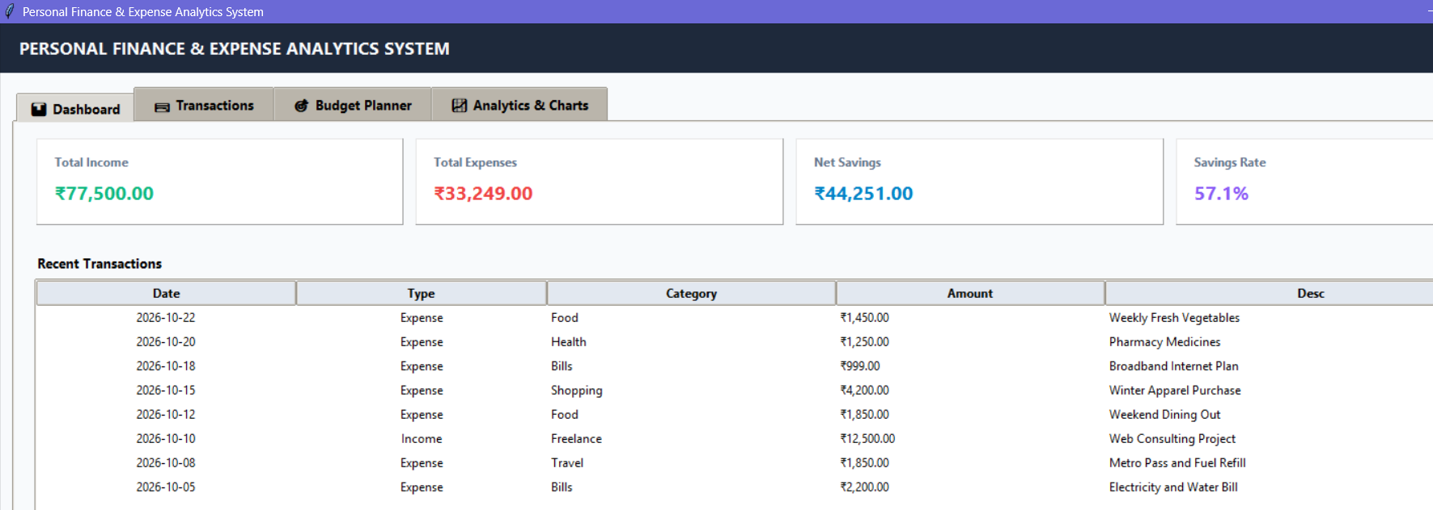
Figure 15.1: Dashboard – Displays total income, total expenses, net savings, savings rate, and recent financial transactions.

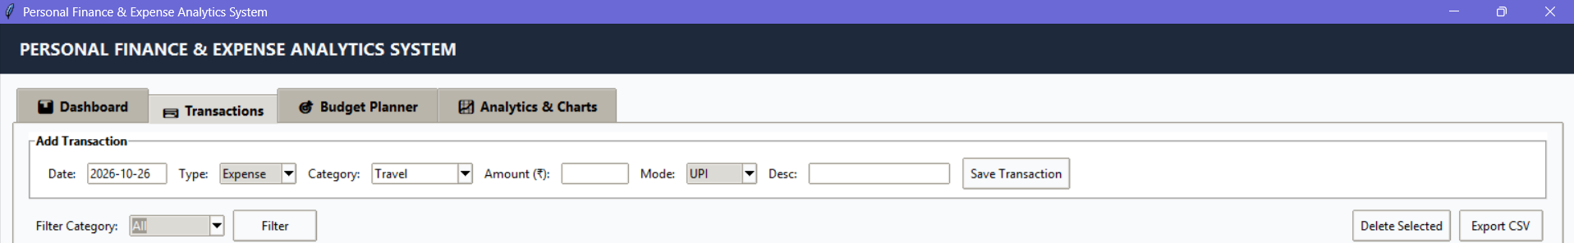
Figure 15.2: Transaction Management – Allows users to add, view, filter, delete, and export income and expense records.

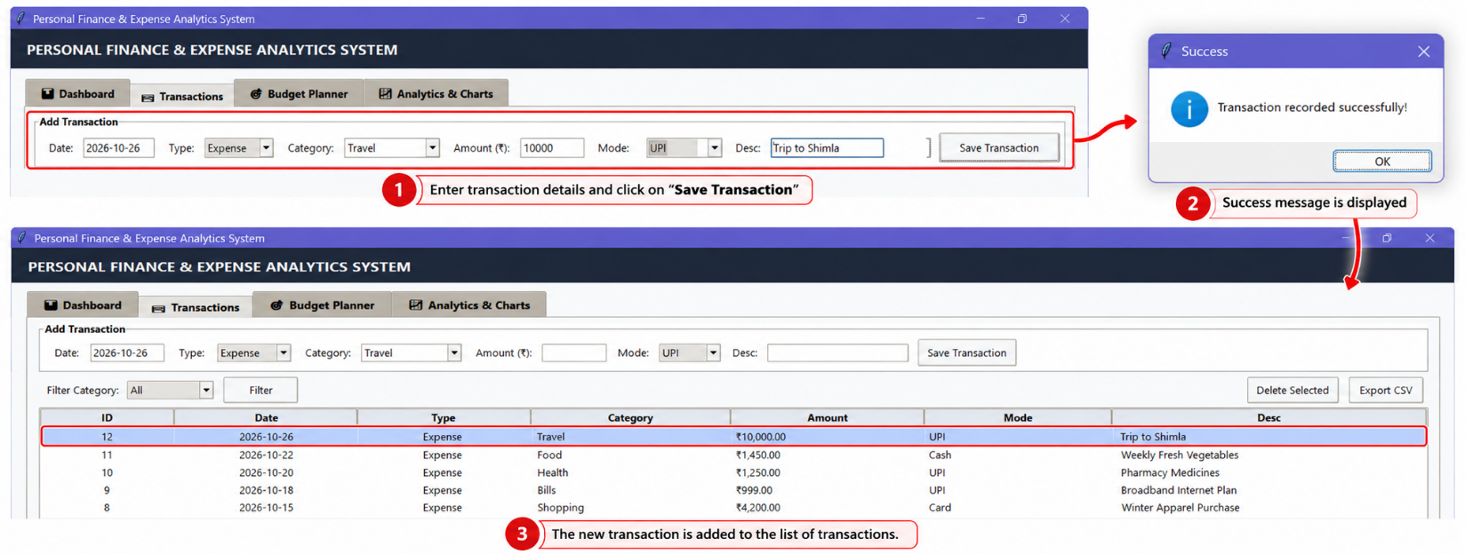
Figure 15.3: Transaction Entry and Successful Record Insertion.

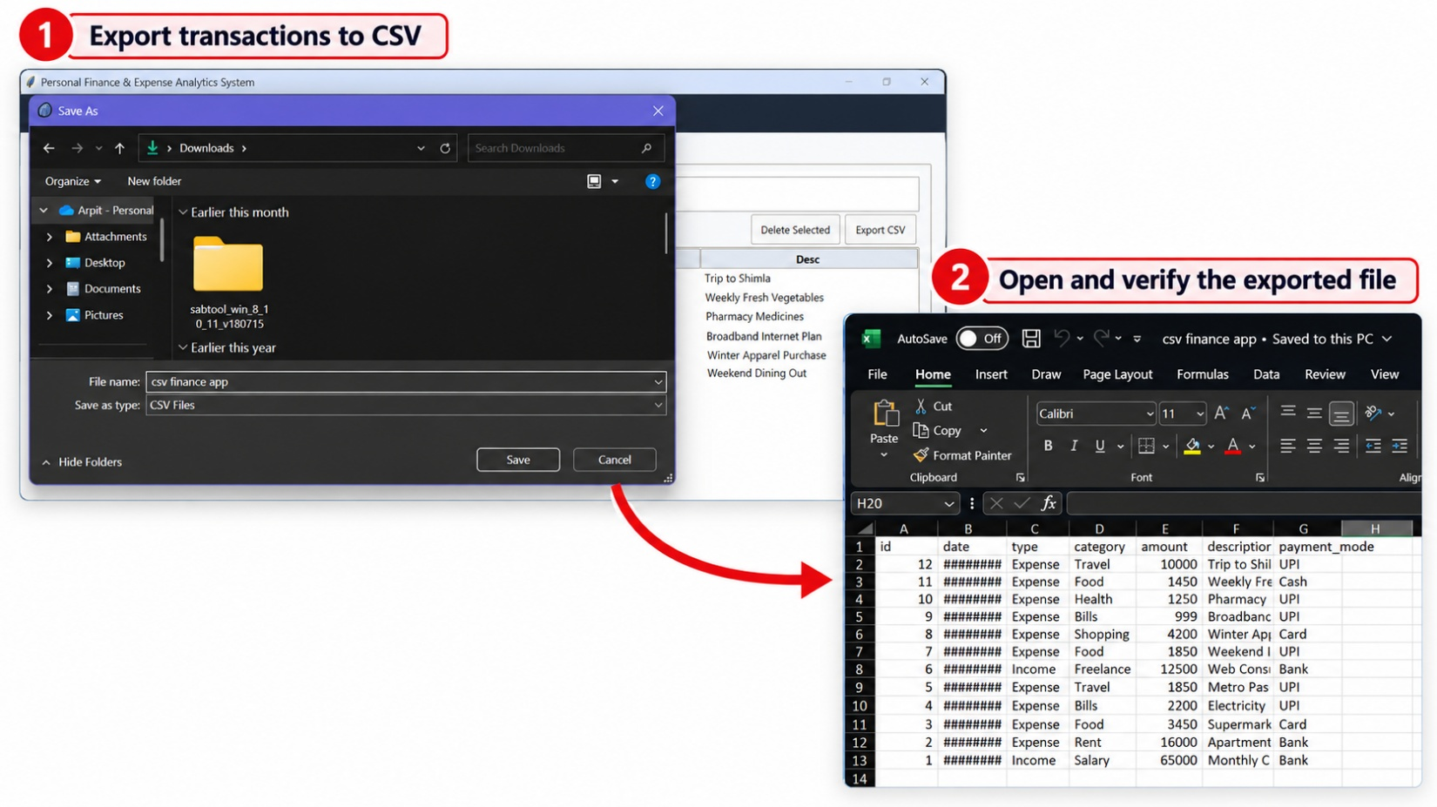
Figure 15.4: CSV Export – Demonstrates exporting financial transaction records to a CSV file and viewing the exported data in Microsoft Excel.

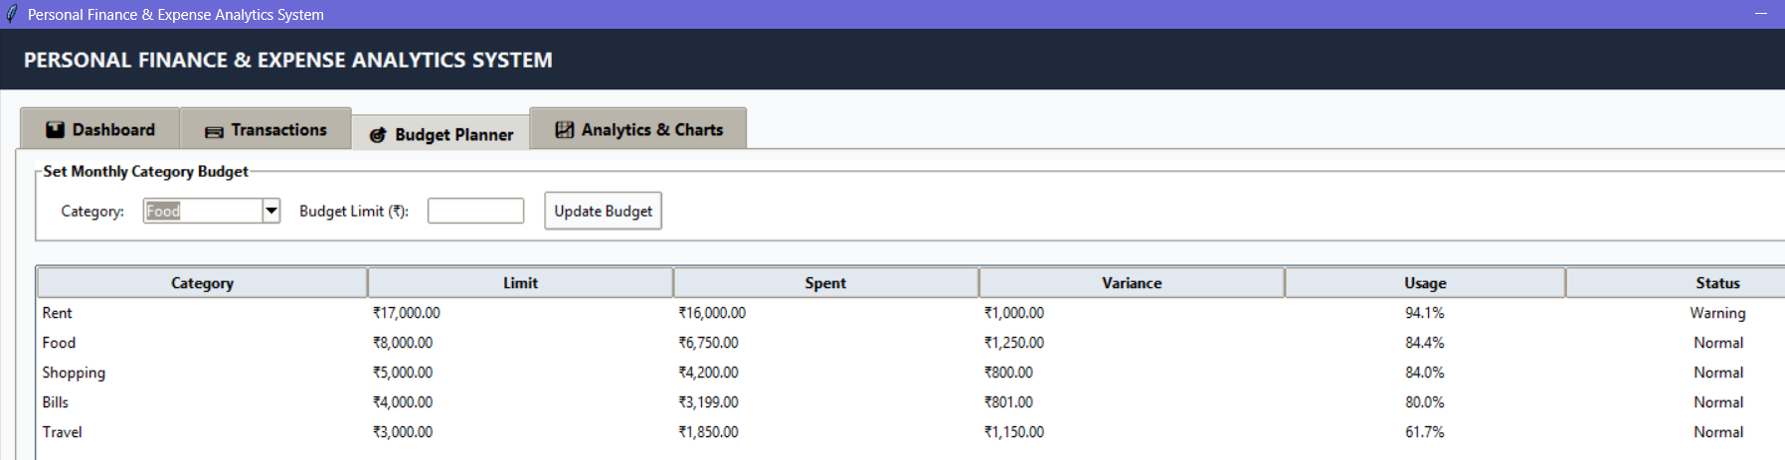
Figure 15.5: Budget Planner – Displays monthly category-wise budget limits, actual expenses, remaining budget, usage percentage, and budget status.

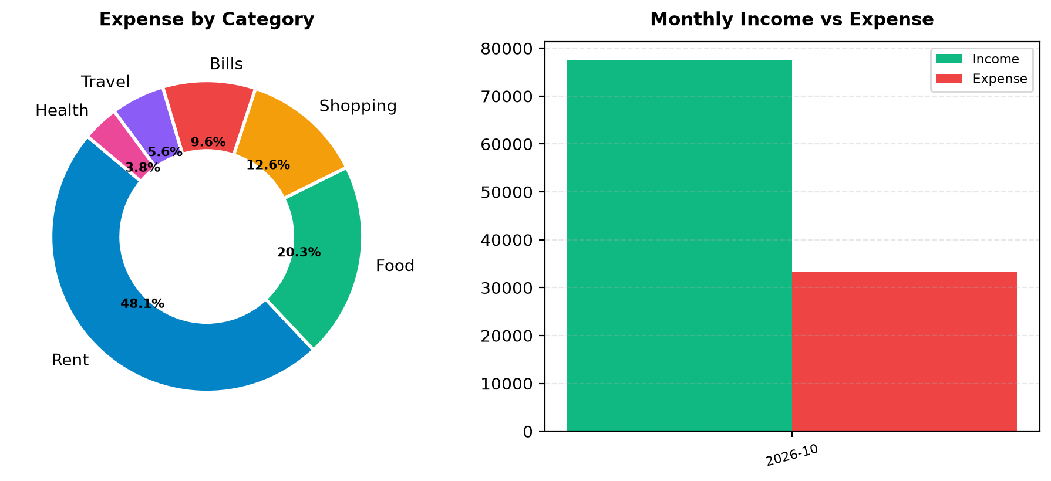
Figure 15.6: Analytics and Charts – Visualizes category-wise expense distribution using a doughnut chart and compares monthly income with expenses using a bar chart.

15. CONCLUSION AND FUTURE SCOPE

Conclusion
The Personal Finance and Expense Analytics System successfully demonstrates how Python can be used to manage personal finances efficiently. The application provides features for tracking income and expenses, managing budgets, calculating savings, analyzing spending patterns, generating charts, and exporting transaction records. By integrating SQLite, Pandas, NumPy, Matplotlib, and Tkinter, the project offers a simple and organized solution for personal financial management while demonstrating practical programming and data analytics skills.

Future Scope
In the future, the system can be enhanced by adding receipt scanning using OCR, machine learning-based expense prediction, automatic budget alerts, recurring transaction management, and cloud-based data backup. Additional features such as password protection, mobile application support, and advanced financial reports could further improve its security, accessibility, and usefulness.

17. REFERENCES
- Python Software Foundation, Python Documentation. https://docs.python.org/3/
- SQLite, SQLite Documentation. https://www.sqlite.org/docs.html
- Pandas Development Team, Pandas Documentation. https://pandas.pydata.org/docs/
- NumPy Developers, NumPy Documentation. https://numpy.org/doc/
- Matplotlib Development Team, Matplotlib Documentation. https://matplotlib.org/stable/
- Python Software Foundation, Tkinter — Python Interface to Tcl/Tk. https://docs.python.org/3/library/tkinter.html
- W3Schools, Python Tutorial. https://www.w3schools.com/python/

